1. Downloading data set

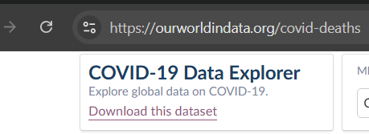

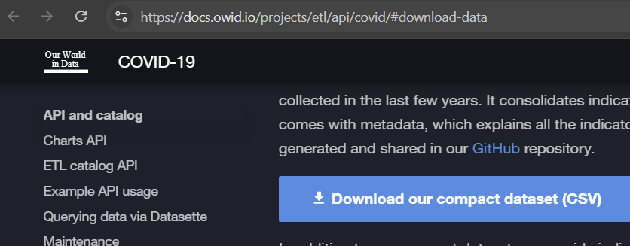

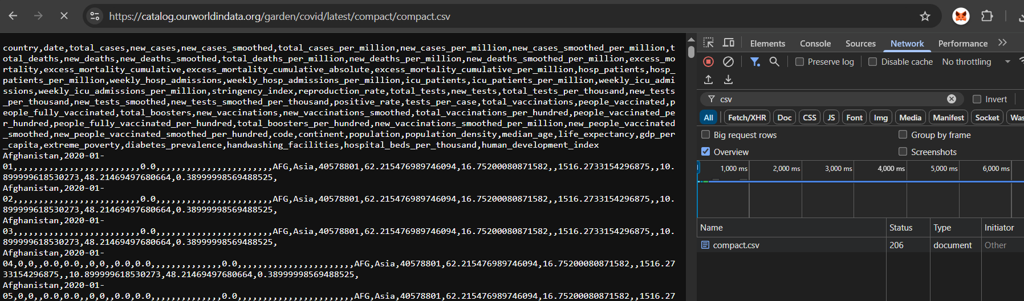

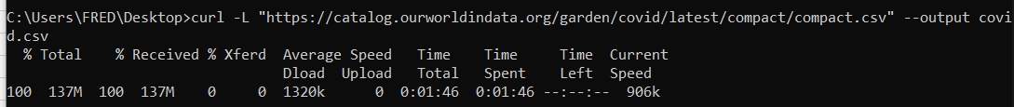

1. Arrange data in csv to see properly the column names

The shortcut key in Excel to **auto-fit column width** based on the data is:

**Alt + H, O, I**

Here’s how it works:

1. Select the columns you want to adjust.
2. Press Alt → then H (opens the Home tab)
3. Then O (opens the Format menu)
4. Then I (selects AutoFit Column Width)

Crtl +Shift + right arrow =select all column to the right of the selected column

1. You need to save the file in excel workbook (*.xlsx) to be able to upload to sql. DO NOT USE *.csv extension

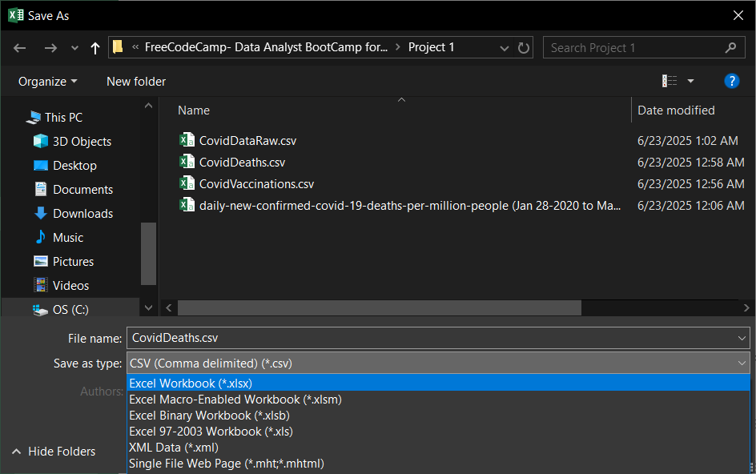

1. Go to the server folder in start menu and open the export and import Data file

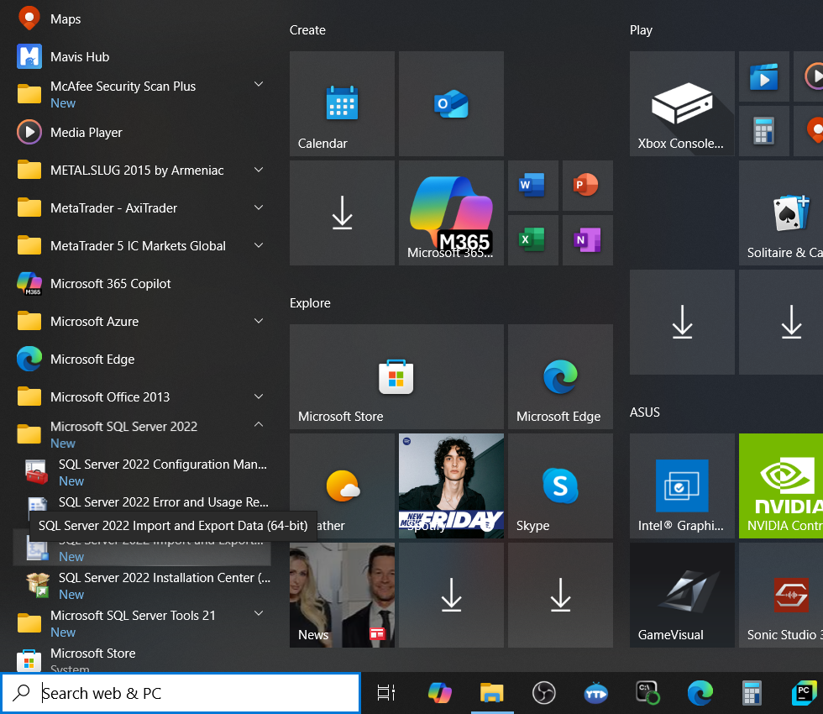

Normal importing is here but it is not working

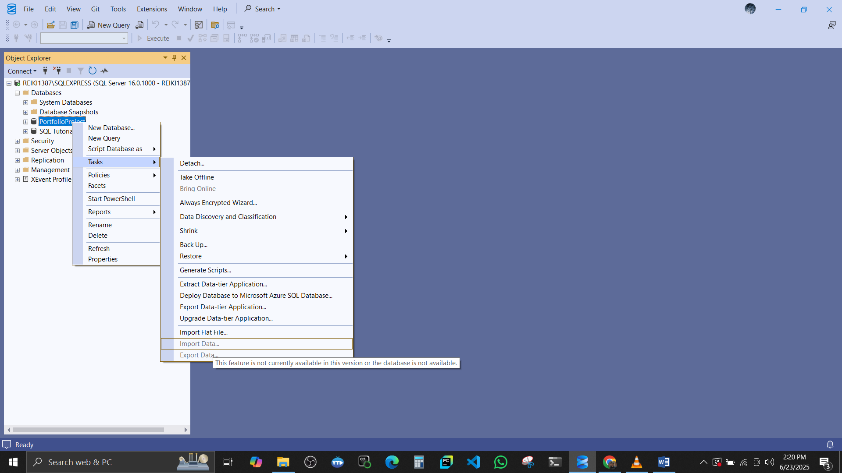

5.